District 11 Annual Report & Awards Process
The attached Annual Report Forms must be completed for all clubs by the outgoing President in cooperation with the outgoing Board and submitted to your Area Director by the end of the day on May 15th. To be most beneficial, completion of the report should be done jointly by the previous and current year's officers. This is the best time to teach the new officers about the operations of your club.
The focus of this process is to create a historical record of club activities for your club and serve as an evaluation for strategic planning.
**This report is limited to 20 pages including attachments and should have a consistent font throughout**
**Reports exceeding 20 pages will not be considered for District 11 Club of the Year**

Area Directors will use the reports to determine and share best club practices. Points will be awarded for outstanding performance in each of the following six categories:
District 11 Awards Categories
- Service: 20 points maximum
- Advocacy: 20 points maximum
- Membership: 20 points maximum
- Monetary Contributions: 20 points maximum (10 pt. bonus for 33% ZIF contribution)
- Fundraising: 10 points maximum
- Community Image / Public Relations: 10 points maximum

Clubs should limit the report to their top two projects for EACH category. Any additional projects for a category may be listed on the last page of the category section with a one sentence explanation of each project. Anything longer than one sentence will not be considered.
Recognition Levels:
- First Level – Area Level - Clubs will receive special recognition, at the discretion of the Area Director (AD), for outstanding performance in each category. A club could be nominated and selected in multiple categories.
- Second Level – Candidate for “District 11 Club of the Year” - The Area candidate for “District 11 Club of the Year” will be selected based on total points earned. Each Club is judged in the six key categories (above) and can earn a total of 100 points, plus 10 bonus points for contributing 33% to ZIF, based on performance in each category. The categories align with the goals and mission of Zonta. The method of announcing the Category and Overall winners within each Area is at the discretion of the Area Director and can include, but is not limited to:
- A conference call with the Club Presidents within the Area
- Winner Announcement via social media or email to all members
- AD visits winning club to announce and celebrate
- If geography is not an issue, an event for clubs within the area
- Third Level – The 6 Area candidates are finalists for “District 11 Club of the Year” and will be submitted by the Area Director to the District Board. The six finalists for the “District 11 Club of the Year” will be honored at the Zonta International Convention in Chicago, Illinois where the Rosa E. Fiol Membership awards, and the “District 11 Club of the Year” and Runner-up will be announced. Time and place to be determined.
Points | Category | *Suggested Number of Pages
20 | Service | 3
20 | Advocacy | 3
20 | Membership  - Strategic Plan and Mentoring Docs – Print 2/4/6pgs to one page. | 4
20 | Monetary Contribution | 2
10 | BONUS Points for contributing 33% to ZIF | NA
10 | Fundraising | 3
10 | PR and Community Image  - Size photos to fit several to one page,  - Print press releases 2/4/6pgs to one page, and  - Provide electronic links to TV/Radio coverage. | 4
NA | Contributor’s List | 1

*The Suggested Number of Pages column is only a gauge to help you not exceed the 20-page limit.

Instructions to print multiple pages to one sheet:
- Click on Print to open your printer info/detail window
- Locate in settings the info to print ‘1 Page Per Sheet’ – as seen below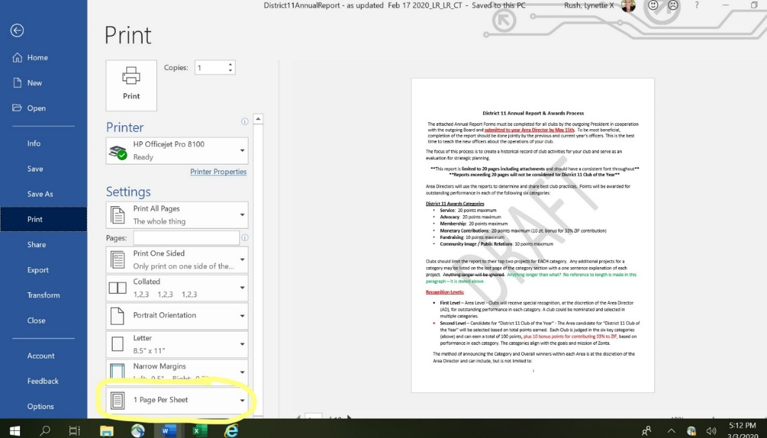
- Click on the dropdown/carrot to select the number of pages per sheet 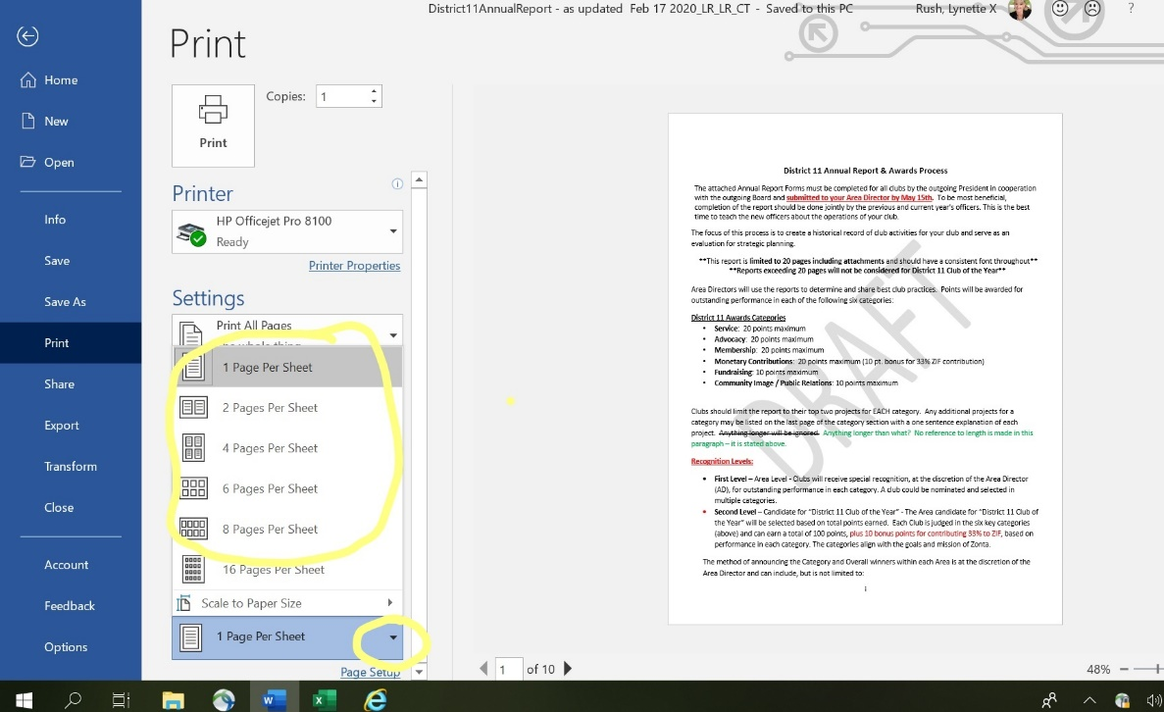
- Click ‘Print’ to produce the sheet with multiple pages

These screenshots are using Internet Explorer 10 – your screen view may vary depending on the version of Explorer you are running on your computer. Obviously, Apple print details will vary as well.
Worst case scenario google how to print multiple pages per sheet for your version of Explorer and/or computer type.

ANNUAL REPORT FOR THE ZONTA CLUB OF
Service Form (Copy form for second service project if needed)
A club may submit up to two projects using a separate form for each project. Any additional projects may be listed on the bottom of the second project page with a brief one sentence description.
Name of Project:
Category of Project: 1 2 Please select box based on the categories provided below:
- Service projects that empower women and girls in general to achieve equal rights and to secure their access to all legal, political, economic, educational, health and professional resources; and
- Service projects focusing on prevention of violence against women and girls.
Date the Project Started: | Click here to enter a date.
It will continue until | Click here to enter a date.
Frequency of project undertaken | Yearly Monthly Weekly Other
Number of members involved
Number of beneficiaries of project
Newspaper, TV, radio coverage | YES NO
Location of Project
Name of Partners other than Zonta (if any)
Role of each partner
In 200 words or less, describe the service project and explain how it benefitted women and/or girls in your community or abroad; also describe any visibility it provided to your Zonta Club.

Advocacy Form (Copy form for second advocacy project if needed)
A club may submit up to two projects using a separate form for each project. Any additional projects may be listed on the bottom of the second project page with a brief one sentence description. If your advocacy project is part of a service project described above, please simply explain how it relates to the service project in a brief statement. Do not repeat.
Name of Project:
Advocacy Project - the expression of support for, or opposition to, a cause, argument or proposal. Advocacy actions may include influencing laws, legislation or attitudes. Zonta advocacy is an action taken in “the public interest” or for “the greater good” with respect to empowering women and girls and their human rights.
Date the Project Started: | Click here to enter a date.
It will continue until | Click here to enter a date.
Frequency of project undertaken | Yearly Monthly Weekly Other
Number of members involved
Number of beneficiaries of project
Newspaper, TV, radio coverage | YES NO
Location of Project
Name of Partners other than Zonta (if any)
Role of each partner
In 200 words or less, describe the advocacy project and explain how it benefitted women and/or girls in your community or abroad; also describe any visibility it provided to your Zonta Club.

Membership Form
- Membership Growth:
(beginning and ending counts will come from District membership records)
- #New members
- # Members lost due to resignation, death, transfer, or other
Has your club been impacted by any extenuating circumstances on your club membership count such as relocation or death? If so, please provide the member name(s) and situation below.

- Membership Retention
Do you survey members?
Do you provide Zonta continuing education for your members?
Do you engage new members in committees and projects?
Did you have a membership event?
Do you have fellowship/Social activities?
Do you have a useful Strategic Plan? If yes, please submit documents (print 2/4/6pgs to one page).
- Membership Participation
Number attending District Conference
Number attending Area Meeting
Number attending other ZI events including UN CSW event in NYC
Number involved with forming a new club
% of Club members with consistent Club meeting attendance
- Member Orientation
Do you have an Orientation Program?
Do you assist new members in registering on the ZI Website?
Describe your orientation program in 200 words or less.

- Member mentoring
Do you have a Mentoring Program?
Describe your mentoring program in 200 words or less.

Membership Form (Continued)
- Sponsor, Organize & Mentor
Has your club been involved in an effort to Sponsor, Organize or Mentor (SOM) a club this year?
If yes, please describe that effort and outcome, including funds used, hours and number of members participating, etc.

Has your club been involved in an effort to revitalize a club this year, including your own?
If yes, please describe that effort and outcome, including funds used, hours and number of members participating, etc.

Has your club been involved in organizing a Z Club/Golden Z Club this year?
If yes, please describe that activity and outcome, including funds used, hours, number of members participating, etc.

Has your club been involved in actively mentoring a Z Club/Golden Z Club this year?
If yes, please describe that activity and outcome, including funds used, hours, number of members participating, etc.

Monetary Contributions Form
Club size will be taken into consideration. Money must pass through the Club Treasury or Foundation and be for project(s) that are on mission and approved by your membership. Non-mission contributions may be considered PR, or do not apply.
Per Zonta International: “Zonta International Foundation (ZIF) and the Zonta International Board strongly encourage each club to contribute one-third (33%) of all service monies raised locally to the Zonta International Foundation in support of the biennial fundraising goals.” Therefore, bonus points will be awarded for clubs contributing 1/3 of all monies raised for charitable purposes to ZIF.
- Itemize local contributions for the year 2019-2020:
Recipient | Amount contributed | Purpose
- How much did your club contribute to Zonta International Foundation (ZIF) between June 1, 2019 & May 31, 2020 (list amounts by category). Do not include individual club member contributions.
Fund | Amount contributed | Per Zonta International: “Zonta International Foundation (ZIF) and the Zonta International Board strongly encourage each club to contribute one-third (33%) of all service monies raised locally to the Zonta International Foundation in support of the biennial fundraising goals.” As such, an additional 10 points will be awarded for contributing at least 33% to ZI this year.
ZISVAW
Jane M Klausman Fund
Amelia Earhart Fund
International Service Fund
Young Women in Public Affairs Fund
Other
TOTAL

Total Contributions
Total Contribution to the Zonta International Foundation (ZIF): | (A) Total from #2 above
Current Year Service Budget Amount | (B) Based on ___Current year fundraising or ____Prior year fundraising
% of Service Budget contributed to ZIF (A)/(B) | %

Fundraising Form (Copy form for second fundraiser if needed)
A club may submit up to two fundraisers on a separate form for each fundraiser. Any additional fundraisers may be listed on the bottom of the third page with a brief one sentence description. Money must pass through Club Treasury or Foundation Treasury.
Name of Fundraiser:
- Fundraising for charitable purposes (Local service & advocacy, Zonta International Foundation, etc.)
Money raised (US $)
Estimated money raised per member
Fundraising hours
Frequency of fundraisers undertaken | Yearly Monthly Weekly Other
% of club members involved
Who are the beneficiaries of the funds raised?
Number of beneficiaries
Newspaper, TV, radio coverage | YES NO
Location of Fundraiser(s)
Name of Partners other than Zonta (if any)
Role of each partner
In 200 words or less, describe the club’s Fundraiser and how it benefitted women and/or girls in the community or abroad; also describe any visibility it provided to your Zonta Club.

- Fundraising for club operations (expenses such as sending delegates to Area, District & International, accounting, legal &/or officer expenses, reserves, etc.)
Money raised (US $)
Money raised per member
Fundraising hours
% of club members involved
Describe your fundraising efforts and how the monies have been or will be used in 200 words or less.

Community Image / Public Relations Form
Which web/social media tools are used by your club? (check all that apply)
Website URL:
Facebook URL:
Twitter URL:
LinkedIn URL:
YouTube URL:
Instagram URL:
Meetup.com URL:
Others
In 200 words, describe activities and if relevant submit best practice samples of how your club promoted Zonta and raised awareness in your community. Include publicity highlights, public awards and/or recognitions, and an estimate of the number of PR spots achieved in newspapers, radio, TV, billboards, Facebook or the web. Submit photos, press releases, or links to this information keeping in mind the 20-page limit for the report.

The following individuals contributed to the completion of this report for the Zonta Club of
NAME TITLE

